19. Plot of a WOODCOCK Diagram
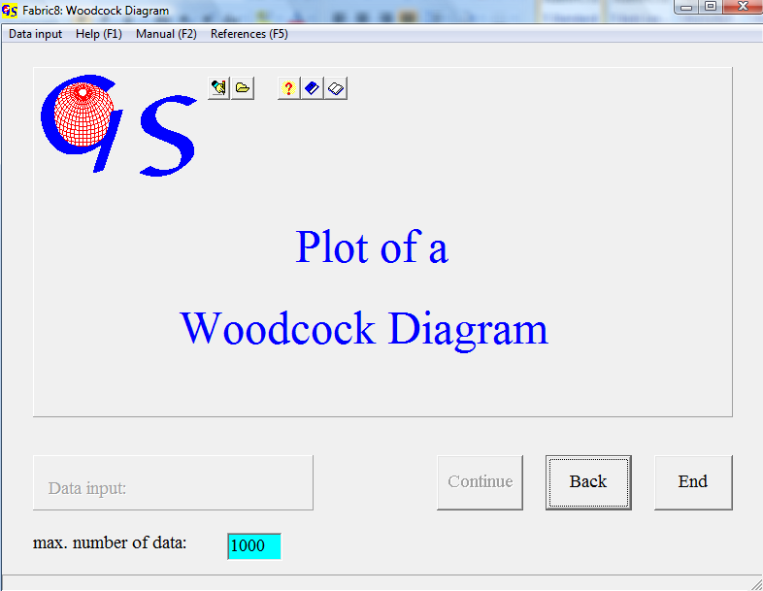
Fig. 1

This program (Fig. 1) draws a diagram after WOODCOCK (1977). It plots the ratios of eigenvalues of orientation tensors in a diagram. This diagram is comparable to the Flinn-diagram (Flinn, 1968). The following ratio is plotted:

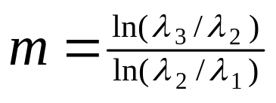
(λ₁ < λ₂ < λ₃ are the eigenvectors of the orientation tensor)

The line with the slope m = 1 is the border between a cluster field with

m>1
and a girdle field with
m<1.

On the ordinate the transitions between isotropy (in the origin) and parallel orientation (cluster distributions) plot. The abscissa contains transitions from isotropy (in the origin) to great circle distribution. Since the degree of preferred orientation increases with the distance from the origin, the ratio

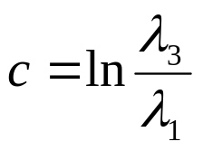

is a measure for preferred orientation.

The form for manual data input is shown in Fig. 2.

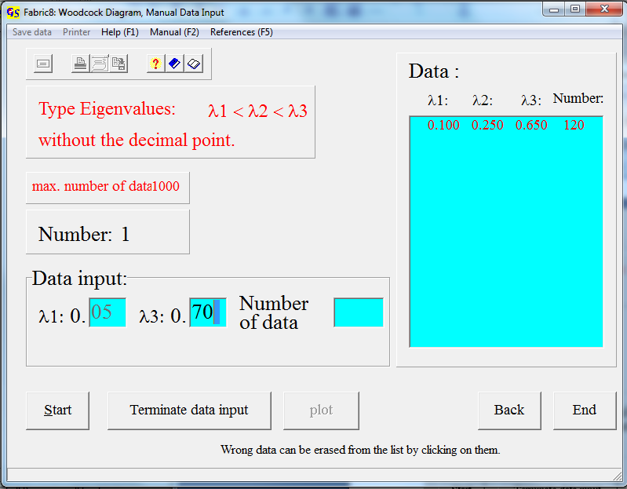Fig. 2

Fill in only the digits after the decimal point of λ₁ and λ₃.

Input from a file is the same as in all other programmes.
The extension for data files is “.WOO”.

Fig. 3 shows the graphic form (e1<e2<e3 equal λ₁,λ_{2 a}nd λ₃).
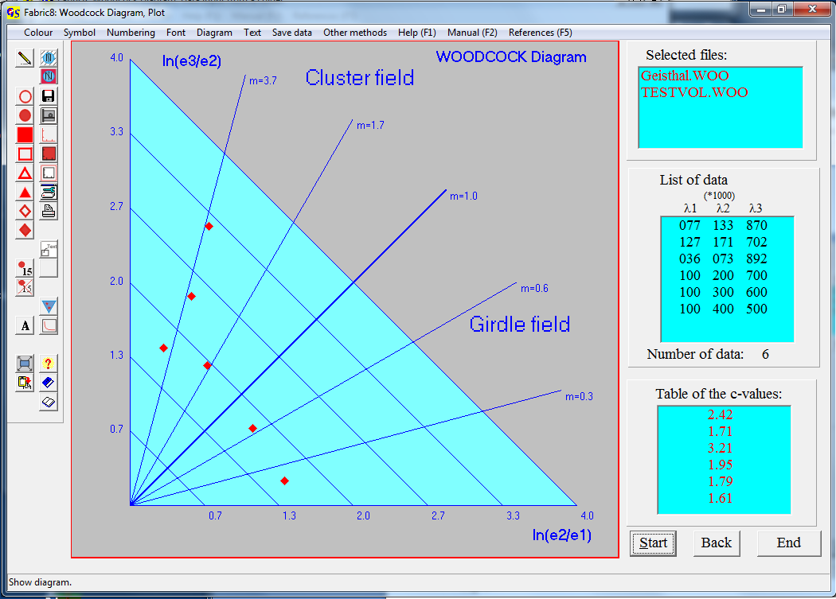
Fig. 3

The table on the right side shows the calculated c-values for these eigenvalues. the c-value lies between 0 (isotropic distribution) und ∞ (max. preferred orientation.
With the option “Numbering/Yes” you put numbers on the data points (Fig. 4)
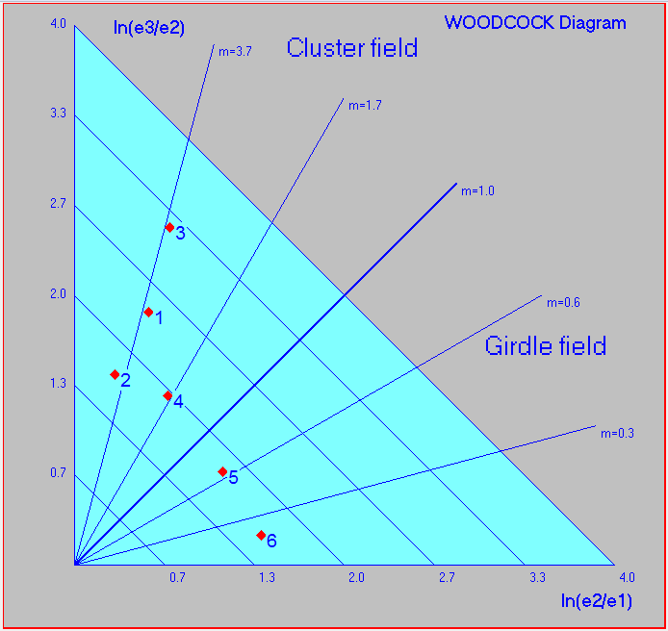
Fig. 4

The options of the menu "Diagram" are explained in program 3.
The menu "Other methods" allows you to jump to the programs 19 or 20 (“Vollmer diagram” or “Test of significance”).

